Lab Report

Your Information
Your Name: Joshua Zimmerman-Gibson
Assignment Title: Build a Simple Predictive Model

Screenshots
Step 1.2: Load the Dataset
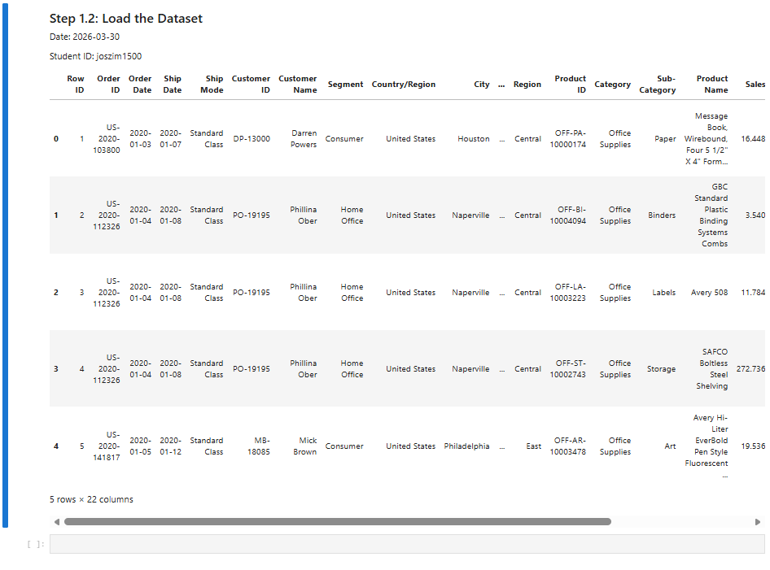
Step 1.3: Initial Exploration of the Dataset
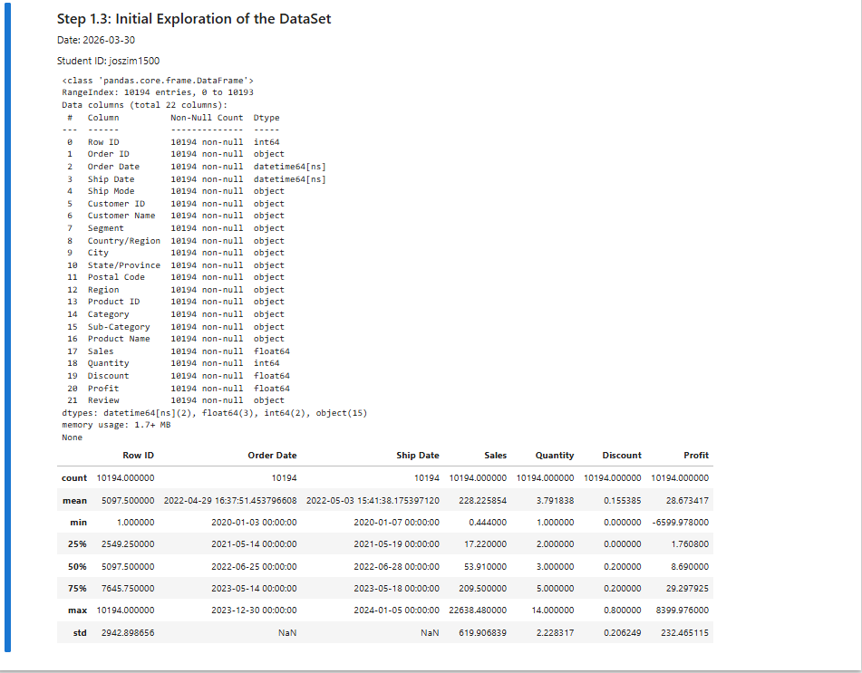
Step 1.4: Data Cleaning
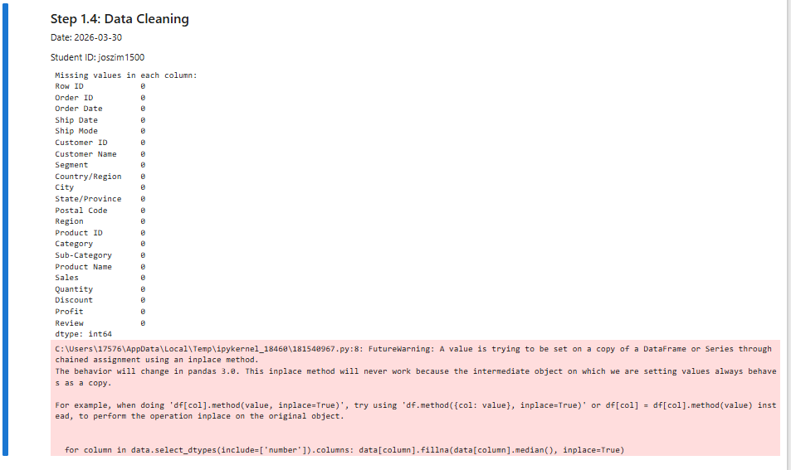
Step 1.5: Feature Selection and Encoding Categorical Variables
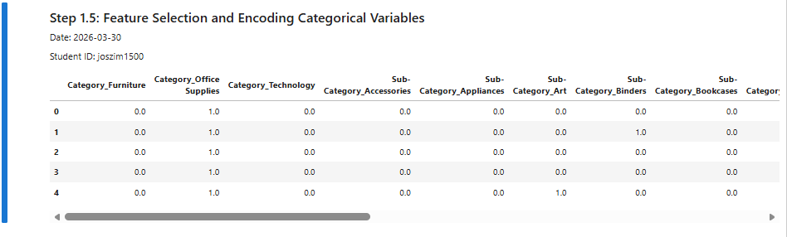
Step 1.6: Prepare the Final Dataset
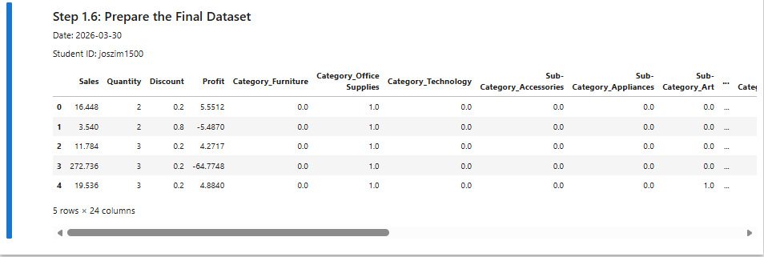
Step 2.1: Data Splitting
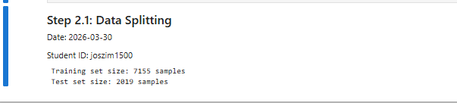
Step 2.2: Model Training
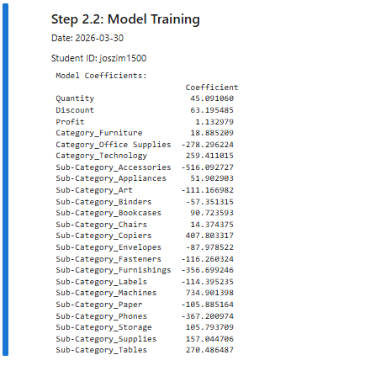
Step 2.3: Model Evaluation
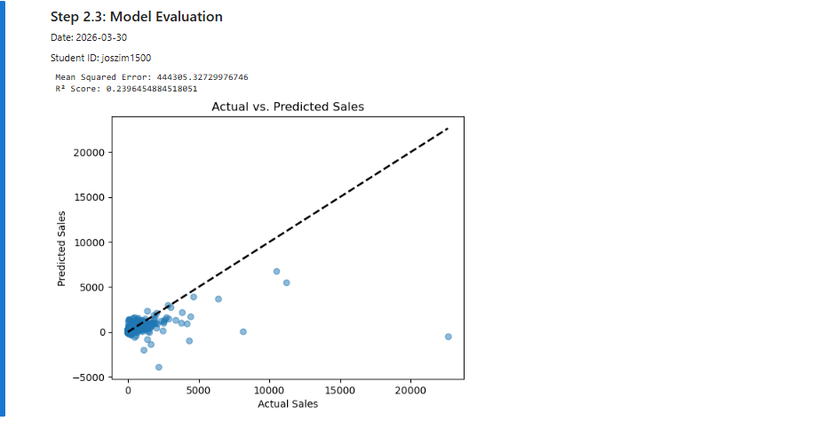
Step 3.1: Preparing New Data and Making Predictions
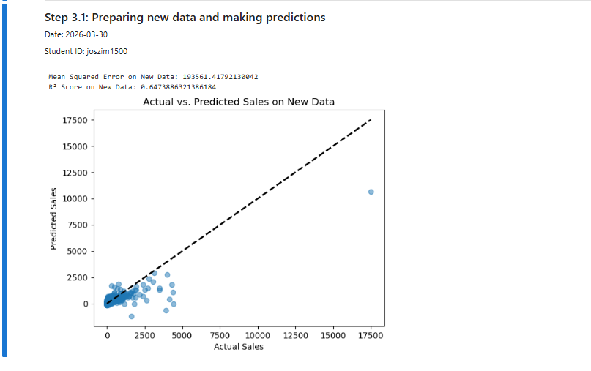
Step 3.2: Analyzing Residuals and Identifying Model Improvements
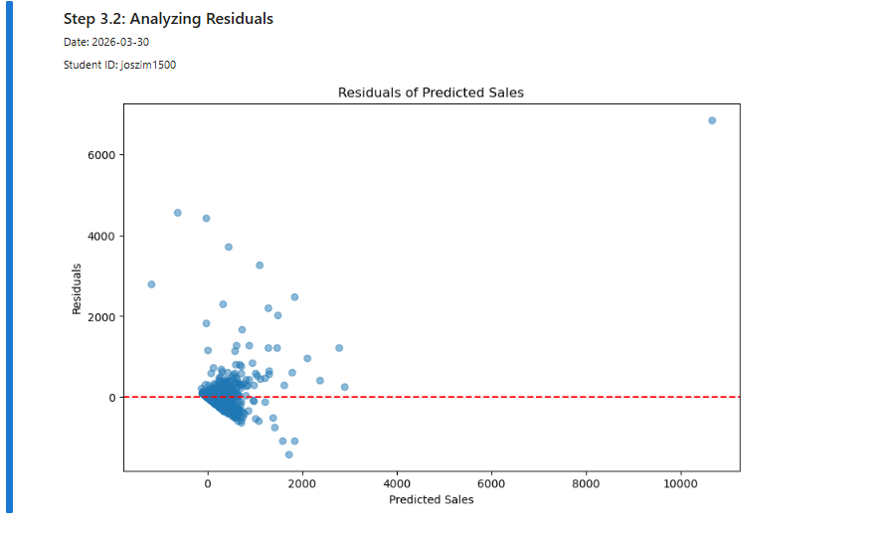

Questions
1. What is the purpose of using the train_test_split function from the sklearn.model_selection
module in predictive modeling tasks, and how does the test_size parameter affect the split?
The train_test_split function is used to divide a dataset into two parts:
- A training set, which is used to teach the model
- A testing set, which is used to check how well the model works on new, unseen data
This helps prevent overfitting and lets us see how well the model will perform in real situations.
The test_size parameter controls how much of the data is used for testing.
For example, if test_size = 0.2, then 20% of the data is used for testing and 80% is used for training.

2. Question: Explain how the LinearRegression model determines the importance of features and how one can interpret the model's coefficients in the context of predictive analysis.
A LinearRegression model learns relationships between input features and the target value by assigning a coefficient (weight) to each feature.
- The size of the coefficient shows how important that feature is.
- A larger coefficient means the feature has a stronger effect on predictions.
- A positive coefficient means the prediction increases when the feature increases.
- A negative coefficient means the prediction decreases when the feature increases.
Each coefficient represents how much the predicted value changes when that feature increases by one unit, assuming all other features stay the same

3. Question: Describe the process and purpose of evaluating a model using mean_squared_error and r2_score from sklearn.metrics after making predictions on test or new data.
After making predictions, we evaluate the model to see how accurate it is.
- Mean Squared Error (MSE) measures the average of the squared differences between actual values and predicted values.
  - Lower MSE means better predictions.
- R² Score (R-squared) shows how well the model explains the variation in the data.
  - An R² value close to 1 means the model fits the data well.
  - An R² value close to 0 means the model does not explain the data well.
Together, these metrics help determine how effective the model is and whether improvements are needed.

